Process Design Document History

# INTRODUCTION

## Purpose of the document.

The Process Design Document describes the business processes chosen for automation using the UiPath Robotic Process Automation (RPA) technology.

This document outlines the process's step-by-step execution as well as the prerequisite conditions and specifications. Developers can use this design document as a starting point to gather the information needed for the robotic automation of the same business process.

## Objectives

This application targets small and medium businesses. It aims to help businesses track and manage interactions with customers and/or employees. It acts as the main place to keep all the information gathered throughout a business’ relationship with its clients.

The objective of this process automation is linked to the project business case and is mainly intended to act as a repository for all business’s customer contacts and data, which gets used by the sales and marketing departments to speed up the sales process and land more deals.

## Process Key Contacts

The specifications document was created using inputs from the process' Subject Matter Expert (SME)/Process Owner and offers clear and comprehensive requirements for the business process.

It is expected that the Process Owner will evaluate it, sign off on the steps' accuracy and completion, context, impact, and a list of process exceptions.

The table below should provide the specifics.

|  |  |  |  |  |  |  |
| --- | --- | --- | --- | --- | --- | --- |
| DATE | VERSION | ROLE | NAME | ORGANIZATION | FUNCTION | COMMENTS |
| 09/07/2022 | 1.0 | Author | Testimony Adams | Grandida LLC | SME |  |

## Minimum Pre-requisites for automation

* Get temporary password for Gmail account from [here](https://myaccount.google.com/apppasswords).
* Gmail account and temporary password stored in Windows Credential as “Gmail_Login”.
* UiPath account with data service enabled.

# AS IS PROCESS DESCRIPTION

## Process Overview

|  |  |
| --- | --- |
|  | **AS IS process details** |
| Process full name | Customer Shelf |
| Function | Storing data |
| Department | Customer Relationship Management |
| Process short description (operation, activity, outcome) | Stores customers’ information and employees’ information.  Sends emails. |
| Role required for performing the process | System 1 User |
| Process schedule | Daily |
| # of items processes/ month | <1000 customers |
| Average handling time per item | 1 minute per customer AND 20 seconds – 2 minutes per transaction. |
| Peak period (s) | No peak period |
| # of FTEs supporting this activity | 1 |
| Level of exception rate | Between 1 and 3 emails sent per month could be missing. |
| Input Data | UiPath Apps (in form of an executable) |
| Output Data | Folder containing excel files of customers’ and employees’ information.  Emails |

## In Scope for RPA

The activities and exceptions in this process that are in the scope for RPA, are listed below

* Full Scope for RPA - the process is to be 100% automated

## 2.2.2 Out of Scope for RPA

There are no activities out of scope for RPA.

## Detailed Process Map

This chapter presents the chosen process in detail, which enables the developer to build the automated process.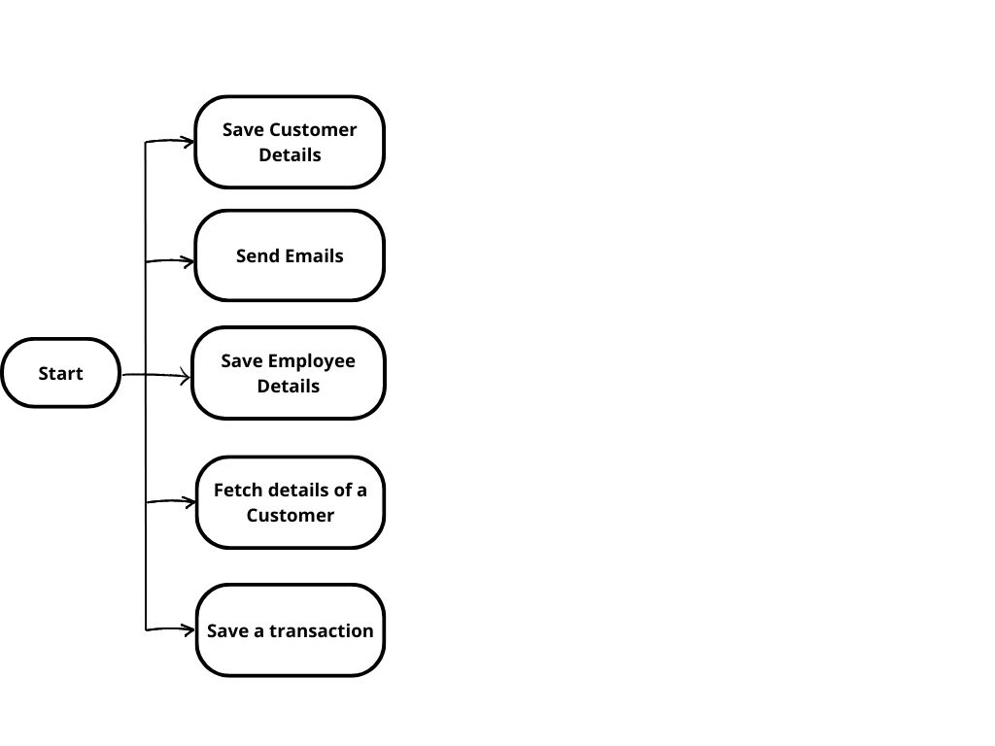

|  |  |
| --- | --- |
| StepShort Description | |
| **1.1** | Open the ACME System 1 web application. |
| **1.2** | Log in to System 1. Requiredinput data: email and password. |
| **1.3** | Access the Dashboard - the central location, where the user can pick a specific menu item. |
| **1.4** | Access the Work Items Listingto view all the available tasks to be performed(Outputdata: list of tasks ). |
| **1.5** | **For each activity** of the WI4 type performthe following steps: |
| **1.5.A** | Open the Detailspage of the selectedactivityto retrievethe Vendor Tax ID (Outputdata: TaxID). |
| **1.5.B** | Go back to the Dashboardand access the Download Monthly Report sectionin the Reportsmenu. |
| **1.5.C** | Fill in the Vendor TaxIDand downloadALL the correspondingmonthlyreportsfor 2017. |
| **1.5.D** | Group all the downloadedmonthlyreportsinto a single Excel yearlyreportwiththe “Yearly-Report-2021- **TAXID.**xlsx” name. |
| **1.5.E** | Upload the resultingExcel yearlyreport in the “Upload YearlyReport” sectionin the Reportsmenu. |
| **1.5.F** | Fill in the Vendor TaxID, set the year as 2021, and select the file on your hard drive. This will return a unique  upload ID. Out upload ID. |
| **1.5.G** | Go back to the Work Item Details pageand select Update Work Item. |
| **1.5.H** | Set the statusto “Completed”. Addthe following comment:“Uploadedwith ID ***uploadID***”. |
| **1.6** | Continue with the next WI4 activity. |